Assignment 3

Q 1. ls - Display hidden files

Ans :

admin1@admin1-HP-Pavilion-Gaming-Laptop-15-ec1xxx:~$ ls . <tab> <tab>

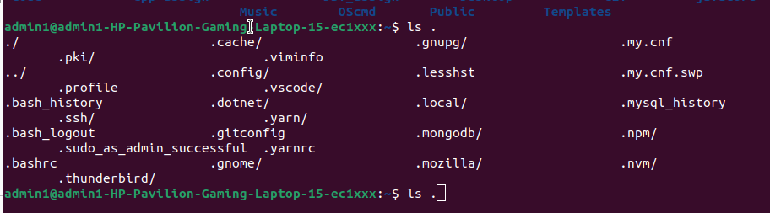

Q.2 rename Rename all *.txt files to *.htm

Ans :
for file in *.txt; do mv -- "$file" "${file%.txt}.htm"; done

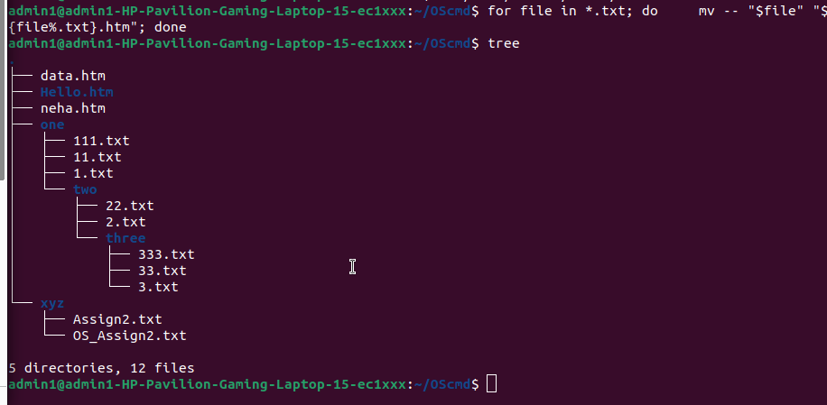

Q.3 ln -s Create symbolic link (shortcut) for a file

Ans :
ln -s Sneha.txt shortcut.txt

Q.4 ln Create hard link for a file

Ans :
ln Sneha.txt shortcut2.txt

Q.5 stat - Display time stamp of the file

Ans :
stat Sneha.txt



Q 6 touch - Change the time stamp of the file

Ans :
touch -t 200111081200 Sneha.txt

Q.7 touch - Create empty file

Ans :

Q.8 tail - Print all lines in a file from fifth line onwards

Ans :

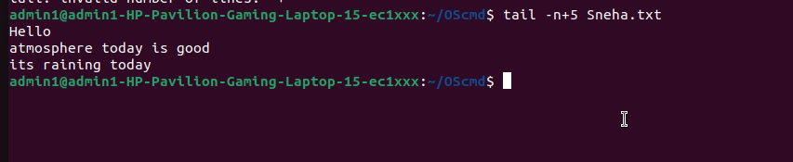


Q.9 init 0, poweroff : Shutdown (Only for super-user)

Ans :
Q 10 init 6, reboot - Reboot (Only for super-user)

Ans :
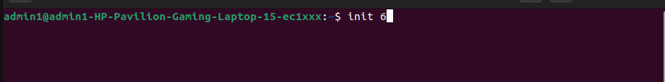

Q 12 whoami Find current user

Ans :



Q.13 tty : Find current terminal

Ans :
tty

Q.14 who am i : Find current user and terminal

Ans :

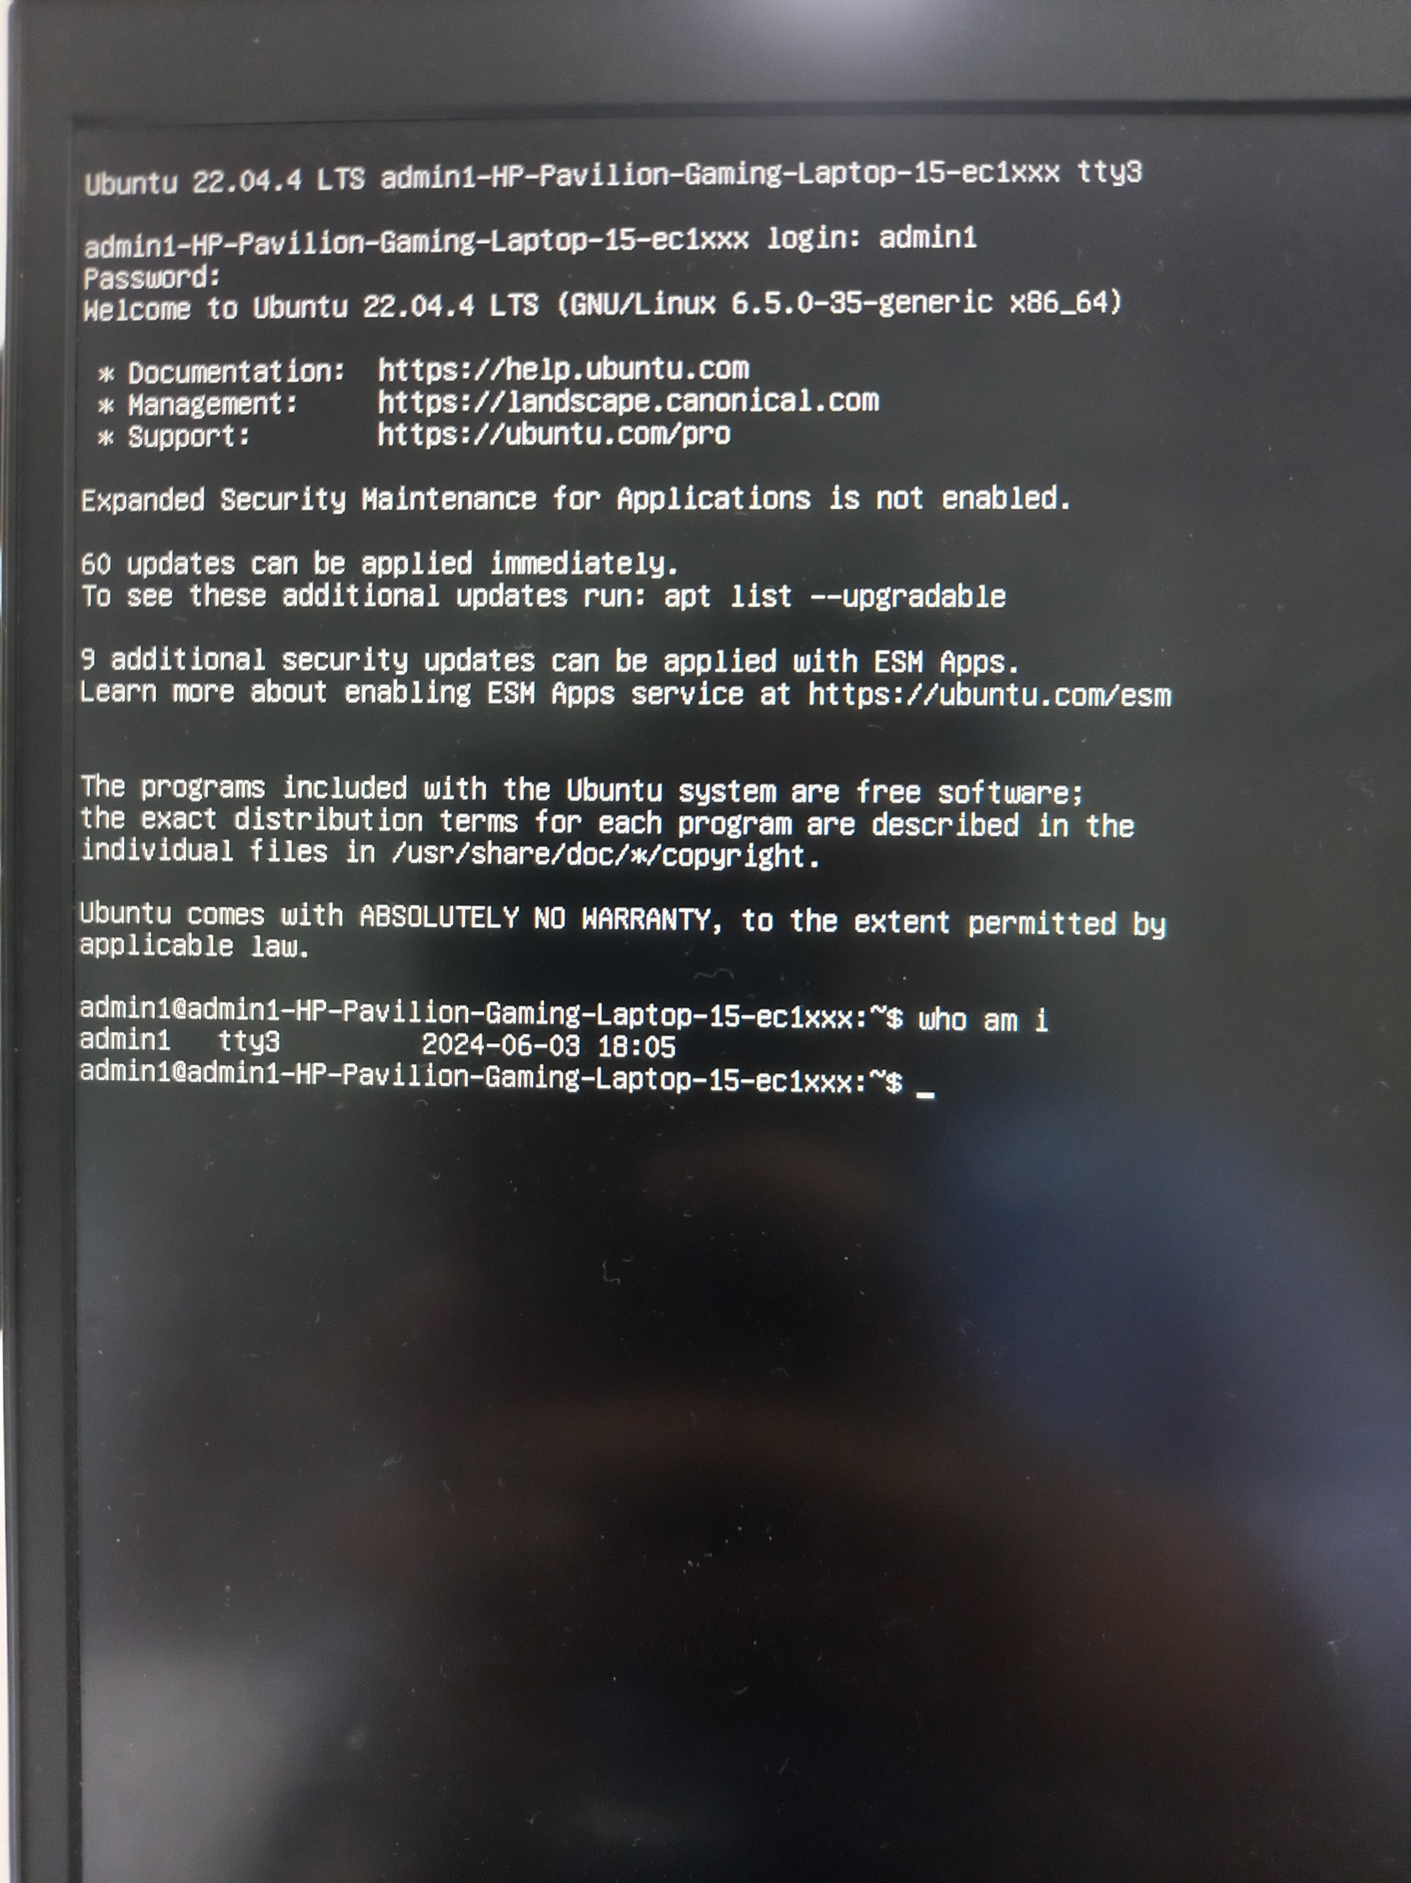

Q 15 users :- Find all users logged into the system

Ans :

Q 16 . who - Find all users logged in and terminals in use

Ans :

Q 17 grep, egrep, fgrep - Find a given word/pattern from the file

Ans :

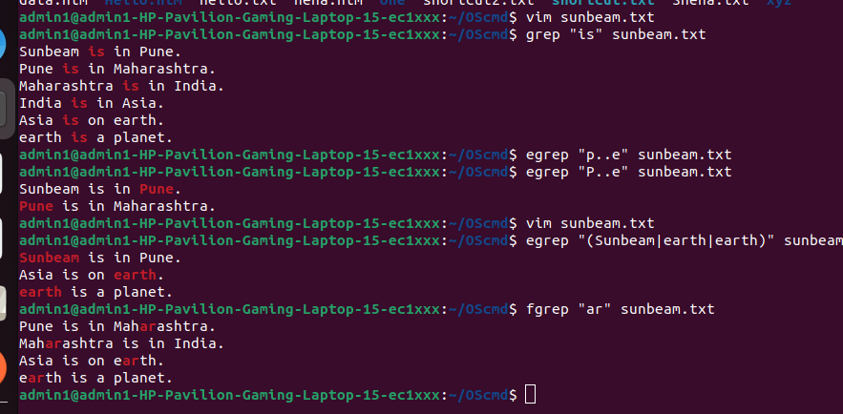

Q 18 chmod : Make a file as read-only

Ans :

Q. 19 chmod : Make a file as write, read and execute

Ans :

Q.20 wc (using redirection) : Take input from the file, count words and store output to other file

Ans :



Q.21 who | wc (using pipe) : Count words in output of “who” command

Ans :


22. Print lines 5 to 10 from the given file

Ans :

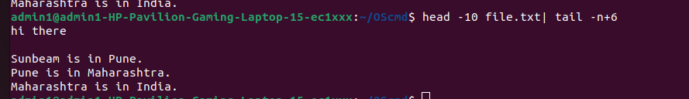

23. Print the uniq values from the unsorted file

Ans : Print the uniq values from the unsorted file

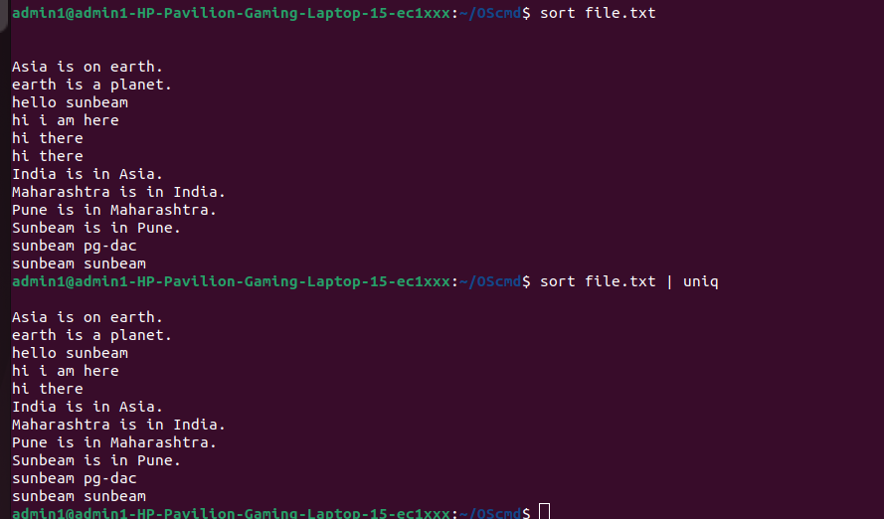

24. Display all users not using tty2, tty3, tty4

Ans :

who | grep -v 'tty[234]'


25. ls - Display all files in ascending order of their file size

Ans :

ls -l | sort -k5 -n
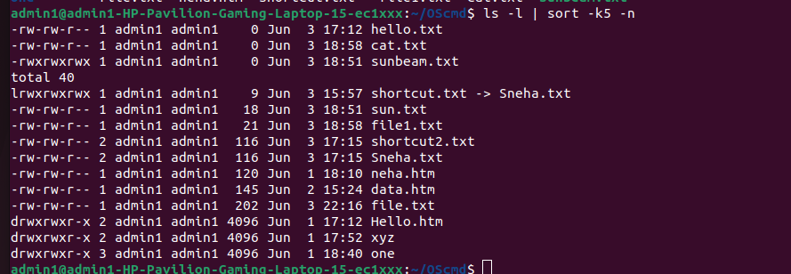

26 . Count number of files and directories from current directory

